**Computer Networks**

**Problem-solving session 1**

**Cisco Packet Tracer: Installation, Deploying and Cabling Devices**

**Objectives:**

Part 1: Download and install Cisco Packet Tracer

Part 2: Getting started with Cisco Packet Tracer

Part 3: Deploy network devices

Part 4: Deploy and cable network devices

**Background / Scenario:**

In this activity, we will download, install, and start working with Cisco Packet Tracer. Then, we will open sample files DeployingDevices.pkt and DeployingAndCablingDevices.pkt, and then locate, deploy, and cable multiple network devices. Then, please save and submit modified files as DeployingDevicesMODIFIED.pkt and DeployingAndCablingDevicesMODIFIED.pkt onto Moodle. Also, please upload a short video on how you have been developing and cabling devices in Cisco Packet Tracer.

**Part 1: Download and install Cisco Packet Tracer**

**Step 1: Create a free account in Cisco Networking Academy www.netacad.com**

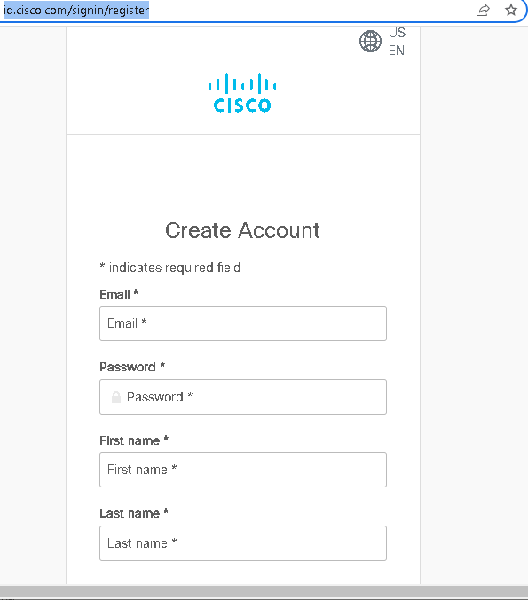

**Step 2: Download Cisco Packet Tracer** (https://www.netacad.com/portal/resources/packet-tracer)

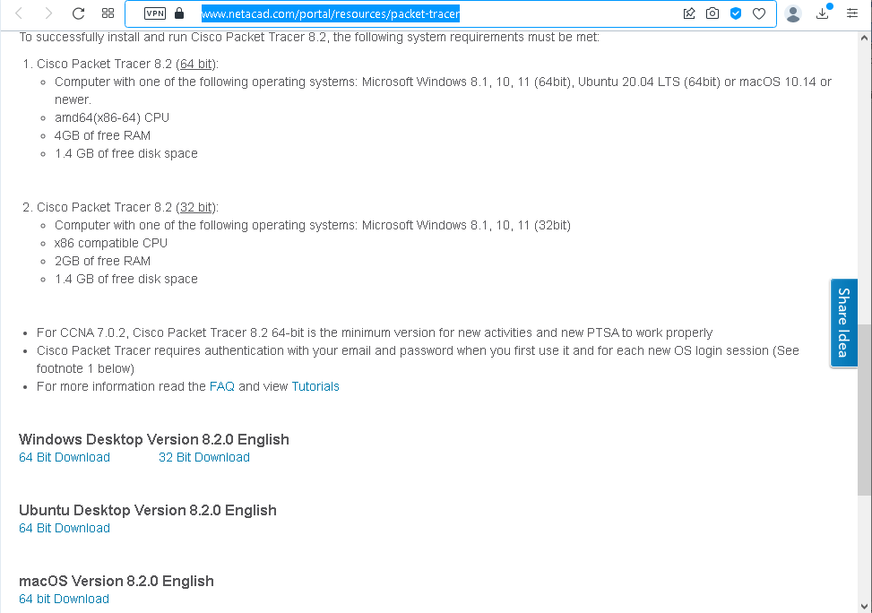

**Step 3: Install Cisco Packet Tracer**

An example of the Cisco Packet Tracer installation on a Windows PC is as follows (https://ipwithease.com/how-to-install-packet-tracer-on-windows-system/):

1. After the **Cisco Packet Tracer download**, click on the downloaded .exe file. Once the below Window will appear, click the “Next” option:

[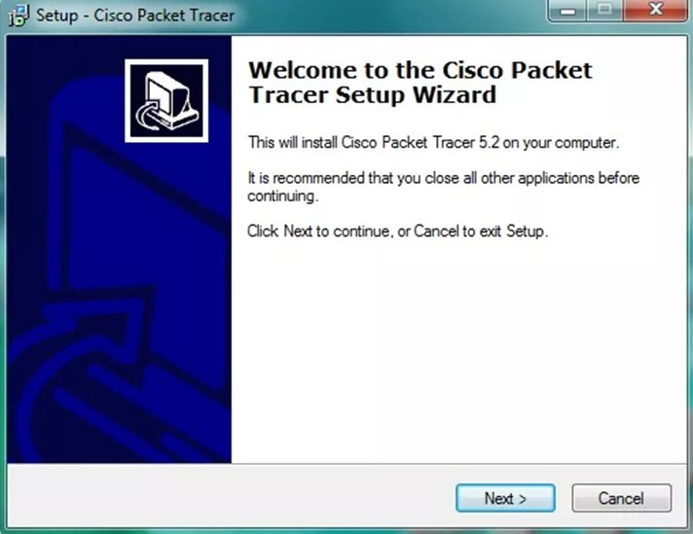](http://ipwithease.com/how-to-install-packet-tracer-on-windows-system/171how-to-install-packet-tracer-on-windows-system-01/)

2. On the next screen, select “I accept the agreement” and click on “Next”:

[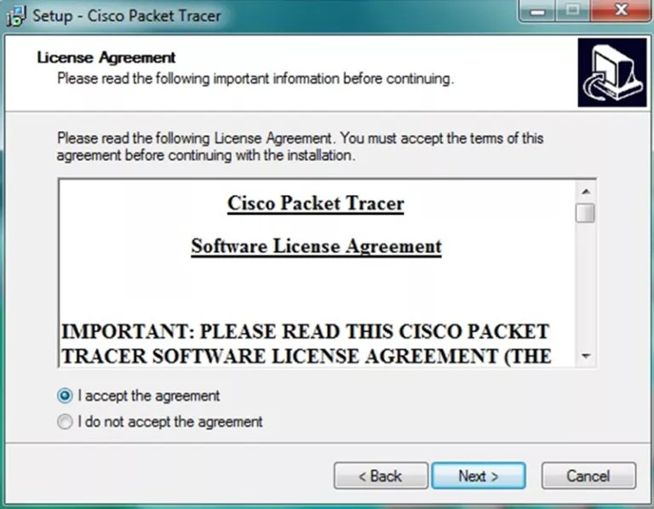](http://ipwithease.com/how-to-install-packet-tracer-on-windows-system/171how-to-install-packet-tracer-on-windows-system-02/)

3. Setup will show the folder in which the program’s shortcuts will be created. If you want to change the folder, you can change it. Click on “Next”:

[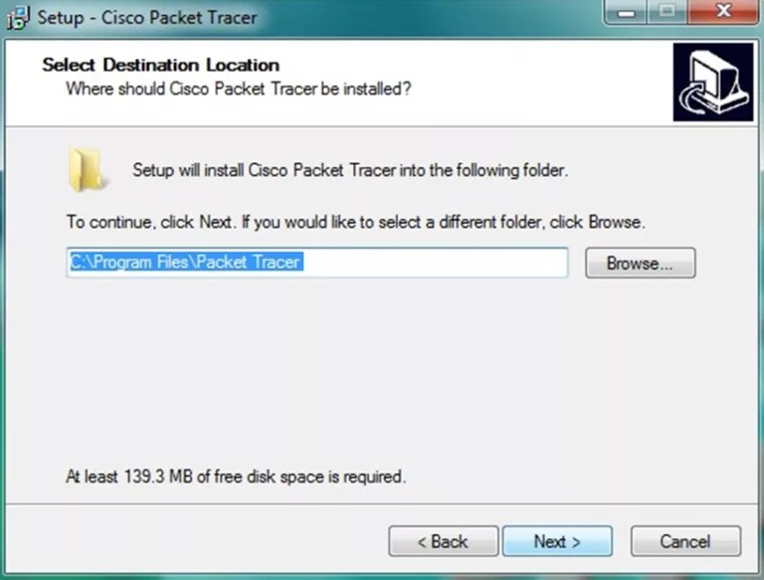](http://ipwithease.com/how-to-install-packet-tracer-on-windows-system/171how-to-install-packet-tracer-on-windows-system-03/)

4. Then, the program will ask whether to create a Desktop icon and create a Quick Launch icon. Make your choice and click on “Next”:

[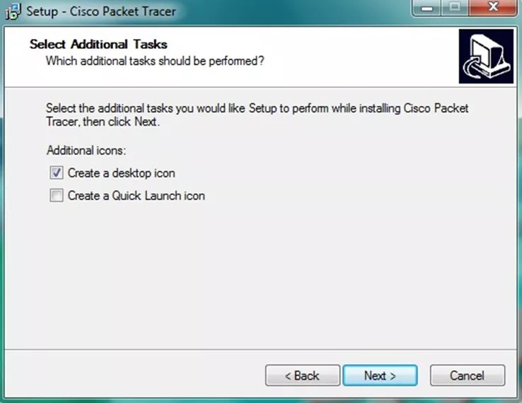](http://ipwithease.com/how-to-install-packet-tracer-on-windows-system/171how-to-install-packet-tracer-on-windows-system-04/)

5. The summary of the settings we selected is displayed. Click on *“Install”*:

[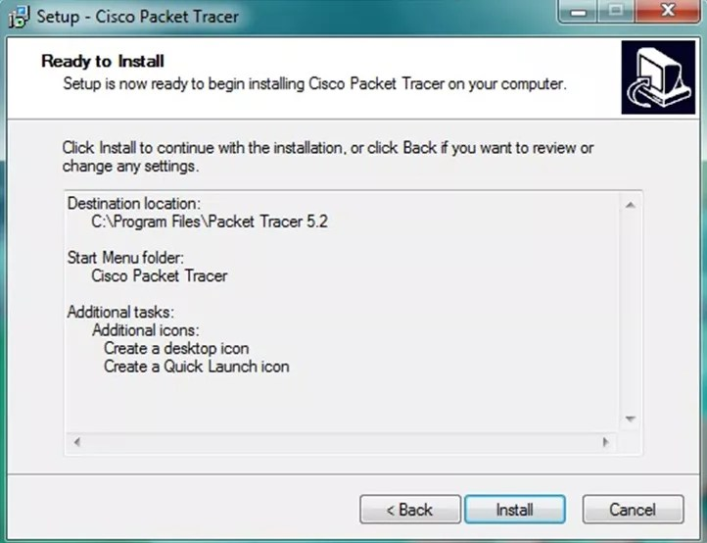](http://ipwithease.com/how-to-install-packet-tracer-on-windows-system/171how-to-install-packet-tracer-on-windows-system-05/)

6. The Cisco Packet Tracer installation starts as shown below:

[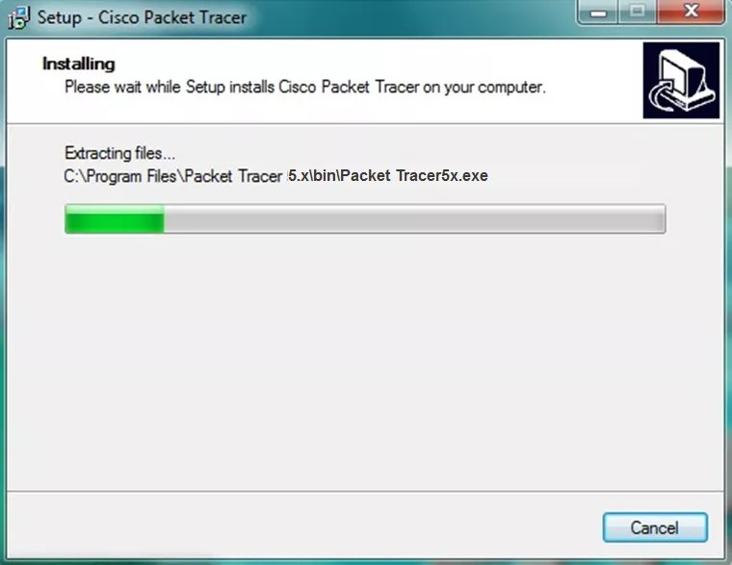](http://ipwithease.com/how-to-install-packet-tracer-on-windows-system/171how-to-install-packet-tracer-on-windows-system-06/)

7. Cisco Packet Tracer Installation gets completed and the below screen is shown. Click on “Finish”. Click “OK” on the next popup asking you to close or restart your computer.

[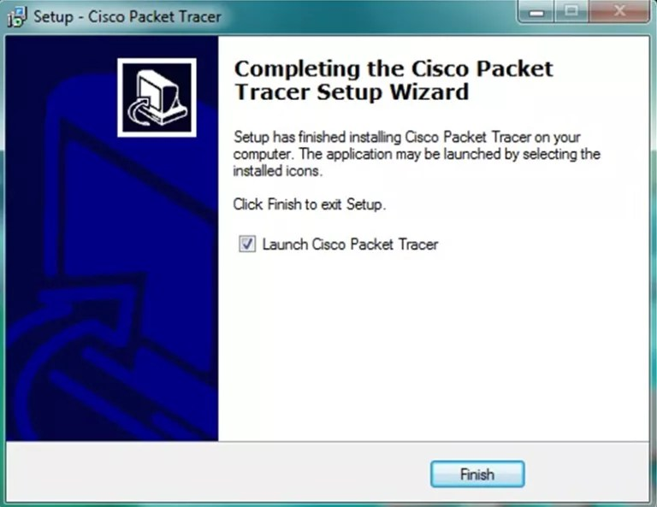](http://ipwithease.com/how-to-install-packet-tracer-on-windows-system/171how-to-install-packet-tracer-on-windows-system-07/)

**Part 2: Getting started with Cisco Packet Tracer**

Double click this icon to watch the video:



**Part 3: Deploy network devices**

**Step 1: Open the Packet Tracer file DeployingDevices.pkt.**

Double click on the DeployingDevices.pkt file to open it. You should be presented with a screen similar to that shown in the figure. If the file does not open, make sure you have properly installed the Packet Tracer application program.

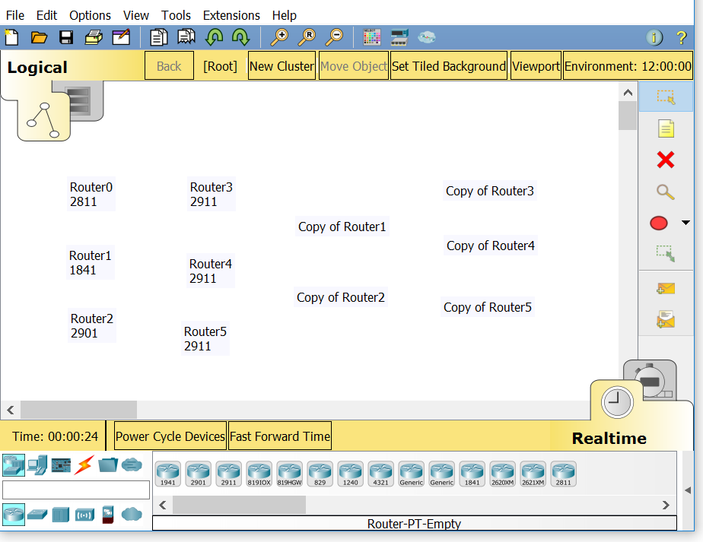

**Step 2: Learn how to Deploy Devices in Packet Tracer.**

**1.** A list of device labels is visible in the workspace. We will use various methods to deploy the listed devices.

**a.** First locate the 2811 router in the Device-Specific Selection Box pictured below.

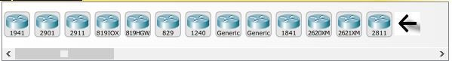

**b.** Using your mouse, click on the 2811 router and while holding the mouse button down, drag the router over the Router 0 label, then release.

**c.** Now click on the 1841 router in the Device-Specific Selection Box and then click on the label Router1 in the workspace.

**d.** Now put a 2901 router on the workspace over the Router2 label.

**Tip #1:** If you want to put multiple devices of the same type onto the workspace, the clicking and dragging can become very tedious. To avoid this, hold down the <CTRL> key as you click on the device in the Device-Specific Selection Box.

**e.** Hold down the <CTRL> key and Click on the 2911 router in the Device-Specific Selection Box. Now click on the labels Router3, Router4, and Router5. To cancel the operation, click on the Cancel Symbol  where the 2911 router was in the Device-Specific Selection Box.

**Tip #2:** The user may also copy devices on the workspace in two ways.

**f.** Method #1: Drag your cursor over the devices that you want to copy.

Drag a box over Router3, 4, and 5, they should appear faded. Hold down the <CTRL> key and drag Router3 over the label Copy of Router3.

**g.** Method #2: Hold down the <SHIFT> key and click on the devices to be copied.

Select Router1 and Router2 (click on Router1 and Router2 while holding down the <SHIFT>key), they will again have a faded look. Point at Router1, hold down the <CTRL> key, and drag the devices over the label Copy of Router1 and release.

Your screen should look like the image below if you have deployed the devices correctly. If the file does not look correct, reload the file, and start over.

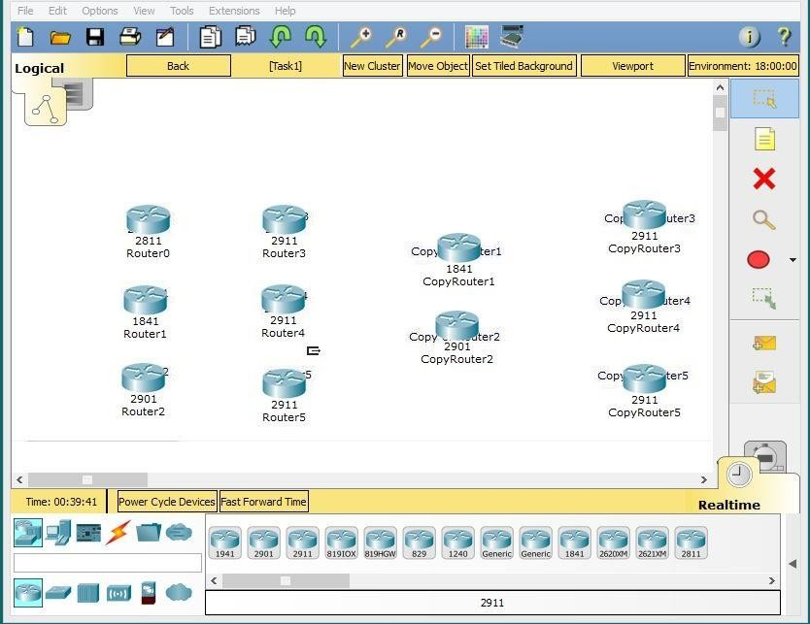

**If the file looks correct, save your activity file as DeployingDevicesMODIFIED.pkt. Then, exit Packer Tracer.**

**Part 4: Deploy and cable network devices**

**Step 1: Open the Deploying and Cabling Devices Packet Tracer file.**

Double click on the DeployingAndCablingDevices.pkt file to open it. You should be presented with a screen similar to that shown in the figure. If the file does not open, make sure you have properly installed the Packet Tracer application program.

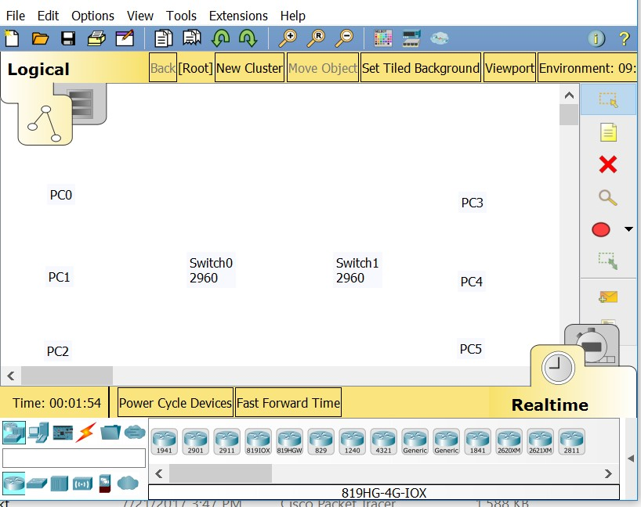

**Step 2: Learn how to Deploy Devices and Cable them in Packet Tracer.**

**1.** The first task in this activity is to practice using the Device-Type Selection Box.

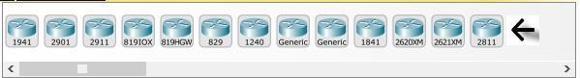

The top row of icons represents categories of devices, and the bottom row represents subcategories:

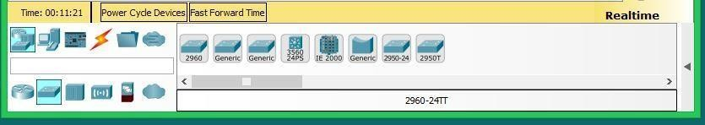

Point at the top row of icons slowly and look at the Label box between the rows, the names of the categories will appear. Now point at the lower row icons and you will see their names appear.

In this activity, we will deploy Switches and PCs. Point at the lower row icons until you see one labeled Switches. Click on that icon and you will see the devices in the Device-Specific Selection Box change.

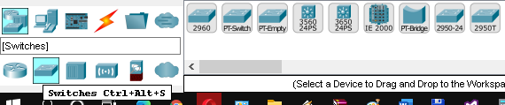

It now shows the switches available in Packet Tracer. Please deploy two 2960 switches over the Switch0 and Switch1 labels in the workspace.

**2.** Now click on the End Device category in the Device-Type Selection Box and deploy six PCs. If you are unsure of which device is the PC just point at the device in the Device-Specific Selection Box and look at the label area below the devices, it should say PC-PT (remember that you don’t have to select the PC icon six times to deploy them, there is a shortcut). Your workspace should now look like this.

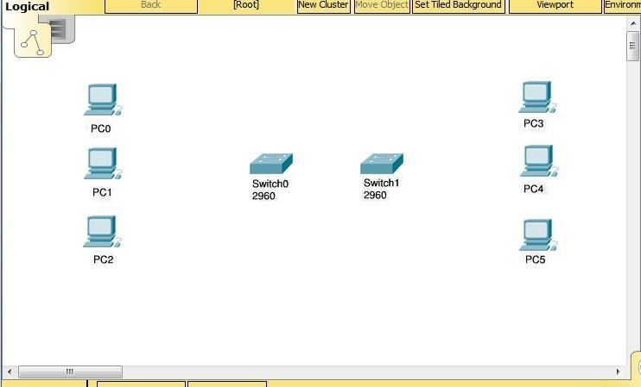

**3.** We are now going to connect the PCs to the switches.

Click on the category that looks like a lightning bolt labeled Connections. In the Device-Specific Selection Box, there will appear a series of cable types, select the Copper Straight-Through cable type. Now point at the center of PC0 and click on it. You will see a pop-up menu appear showing the cable connection types – click on the FastEthernet0 selection. Now a wire will appear anchored to the PC. Point at Switch0 and click on it. Another pop-up menu will appear with a much larger set of selections, point at, and click on the FastEthernet0/1 selection. The cable will now be connected, and two blinking link lights will appear: one green and one amber. The amber light will turn to green after about a minute.

**4.** We are going to cable all six PCs to the switches.

Either select the cable each time or use the <CTRL> key. This is the set of connections to be done:

PC1 FastEthernet0 to Switch0 FastEthernet0/2

PC2 FastEthernet0 to Switch0 FastEthernet0/3

PC3 FastEthernet0 to Switch1 FastEthernet0/1

PC4 FastEthernet0 to Switch1 FastEthernet0/2

PC5 FastEthernet0 to Switch1 FastEthernet0/3

If you used the <CTRL> key doing multiple copies cancel it by clicking on the cancel indicator .

**5.** Now we need a different type of cable to connect the two switches.

Select a Copper Cross-Over cable. Click on it and then point at and click on Switch0. From the pop-up menu select the Gigabit0/1 interface near the bottom of the list. Then point at and click Switch1 and select the same interface from this list. The cable will appear and both link lights will be amber but will eventually turn to green after about a minute.

**6.** The completed activity should look like the following:

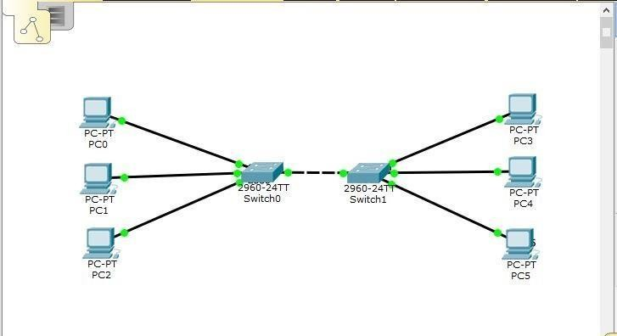

**7. If your workspace looks like the above image, save the file as DeployingAndCablingDevicesMODIFIED.pkt. Then, exit Packer Tracer.**